Some more background on the commercial development application for East Sooke Park

The application has generated a lot of reaction, so I have compiled some of the links etc here. Please feel free to add to the dsicussion with more information etc,

One With Nature
The company that has filed the application with the Province has a website: https://owncorp.ca

- It appears to be a one man show, Vitaliy Svetlichnyy, based in Metchosin
- As far as I can tell, he has no training or qualifications in recognised wilderness education in BC – no mention of guiding, courses, First Aid, navigation , teaching experience etc.
- His offerings seem very removed from ‘leave no trace’ wilderness ethics – with an emphasis on building fire, hunting, making shelters from natural materials etc.
- His interests seem to be hunting, fishing and motorised sports.

Change.org petition
Good information and an active petition to sign:
“Keep East Sooke Park Protected, Public and Not for Profit”
You can read more and sign the petition here:
https://c.org/6JdxpCq6NB

Note: If you do sign the petition, please also give your feedback on the province site, as this is where the decision will be made.

Article from The Tyee
https://thetyee.ca/News/2026/04/09/Provincial-Park-Open-Private-Business/?utm_source=daily&utm_medium=email&utm_campaign=0904

Facebook post from Ian Ward, Colwood Councillor
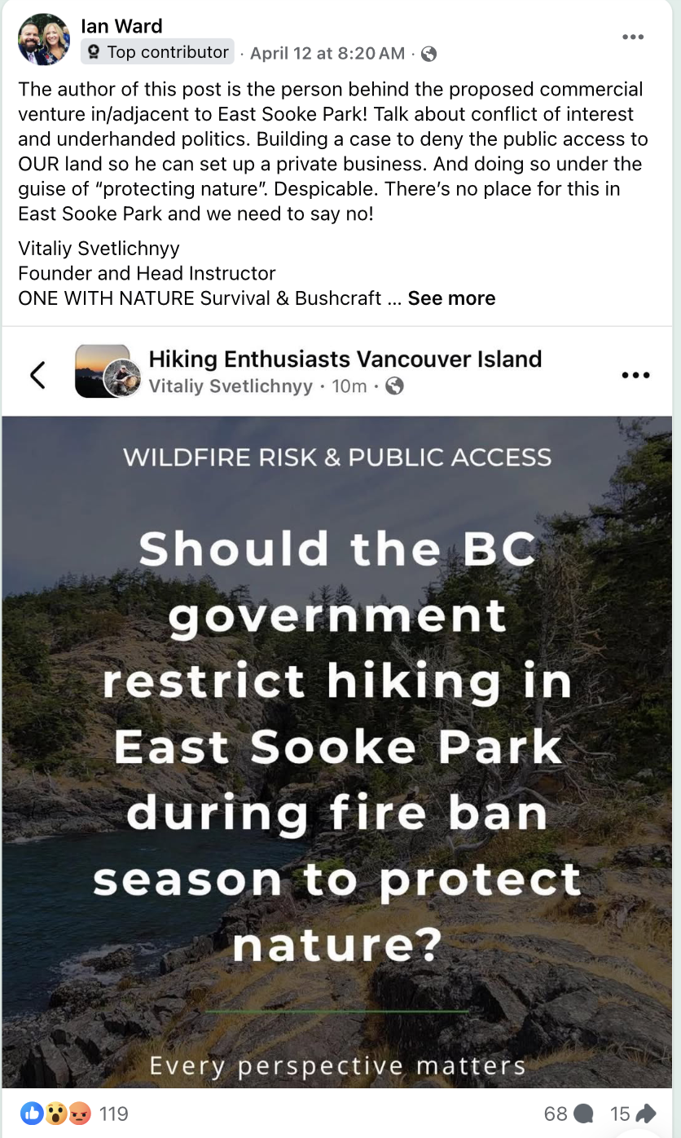
Metchosin Council
In their 20 April meeting, Council unanimously agreed to state their opposition to the application with letters to be sent from the Mayor to the Minister of Water, Land and Resource Stewradship and to their MLA. They are also encouraging all citizens of the municipality to give feedback to the Province on the application.

Catrin
23 April 2026

